Efficacy of Disinfectants on Common Laboratory Surface Microorganisms at R.S Mangaliso Hospital, NHLS Laboratory, South Africa
Pakiso Makhoahle^{1*}, Tshepiso Gaseitsiwe^{1,2}
¹Faculty of Health and Environmental Sciences, Central University of Technology-Free State, South Africa.
²Department of Microbiology, Robert Sebokwe Mangaliso Hospital, NHLS, Robert Sebokwe Mangaliso Hospital Kimberley.
Abstract
This study was conducted to ensure the safety of laboratory employees and minimize exposure to microorganisms or infections by using the right surface disinfectant after every shift. A sterility test was performed to detect the presence of potential microbial contaminants in the 5% BA, MCA, and saline. The common laboratory surface test microorganisms identified were Acinectobacter lwoffii and Staphylococcus Lentus. The efficacy of the disinfectants against each test organism at a 15 min contact time was determined using a quantitative suspension test. Using the agar plate method, a 0.9 McFarland suspension of test organisms was inoculated on the surface bench, and swabs were taken before and after disinfection. Sodium hypochlorite (5 %) was more potent than both 5% and 70% alcohol in the agar plate method and quantitative suspension test. Acinectobacter lwoffii (3.1McF) and Staphylococcus Lentus were completely killed by 5% Sodium Hydrochlorite within 5 min of contact. After 15 min of exposure to 5%, both test organisms survived and both tubes were still turbid when compared to the control tube (suspension of an organism without disinfectants). On the medium containing 3.4 McF and 3.1 McF suspension of test organisms with 1 ml 5%. In contrast, no growth was observed after an overnight incubation.  The outcome of this study further strengthened earlier studies and underscored the need to periodically assess the efficacy of disinfectants routinely supplied to the laboratory to ensure proper control of infections by using the right disinfectant at the right concentration for the right contact time‎. | Keywords: 5% sodium hypochlorite, 70% alcohol, 5%Distal- quaternary ammonium compound, Laboratory surface, Disinfectants, Contaminates
Corresponding author: Pakiso Makhoahle
E-mail pmakhoahle@cut.ac.za

 | This is an open access journal, and articles are distributed under the terms of the Creative Commons Attribution-Non Commercial-ShareAlike 4.0 License, which allows others to remix, tweak, and build upon the work non-commercially, as long as appropriate credit is given and the new creations are licensed under the identical terms.

How to Cite This Article: Makhoahle P, Gaseitsiwe T. Efficacy of Disinfectants on Common Laboratory Surface Microorganisms at R.S Mangaliso Hospital, NHLS Laboratory, South Africa‎‎. Bull Pioneer Res Med Clin Sci. 2023;x(x):xx-xx.

Introduction
Safety is mandatory for everyone working environment that includes the clinical laboratory especially when the environment is dealing with bacteria and other microbes. During the COVID-19 period, every household and even transport and shopping complexes were expected to disinfect to reduce the transmission of the infections. The use of appropriate and reliable disinfectants on surfaces regularly is critical in preventing the transmission of colds, microbial infections, and other sicknesses among health workers [1-3].
In most clinical laboratories hazards such as chemicals, flames, infectious agents, and glassware are present and this inherently makes the working environment dangerous [4, 5]. Exposure to these potential hazards is possible simply through direct contact with contaminated surfaces or through spillages and spattering of hazardous substances on the bench when PPE is not applied [5]. Cleaning plays a huge role in laboratories working with infectious agents or chemicals to minimize risks and improve the quality of results [6]. According to CLSI, a very essential method to ensure the safety of laboratory employees is to utilize good decontamination procedures with the use of effective disinfectants [5, 7, 8].
Decontamination is a process used in laboratories to reduce microbial contamination and minimize infection transmission [9]. Sterilization, disinfection and antiseptic are types of decontamination. Sterilization and disinfection both remove pathogens, but sterilization differs from disinfectants because they completely kill all microorganisms including spores [9-11]. Procedures for sterilization include radiation, heating, steaming, and chemical sterilization; these methods are used to sterilize food, medicine, and surgical instruments [9, 11]. Antiseptics are substances used during surgery or other medical procedure to stop or slow down the growth of microorganisms [12, 13]. The difference between antiseptics and disinfection is that antiseptics are applied to the body whereas disinfectants are applied on non-living objects or surfaces such as cabinets, laboratory work areas, telephones, computer terminals, and equipment [5, 12, 13]. Disinfection is used mostly to decontaminate surfaces or air and for that reason, the purpose of this research will be to study the effectiveness of disinfectants used to decontaminate laboratory surfaces [13]. There are most common disinfectants used to decontaminate laboratory surfaces that include sodium hypochlorite (bleach/jik), alcohols, hydrogen peroxide, chlorine, aldehydes, peroxygenase, and quaternary ammonium compounds [13].
During the early 1960s, 3 categories (non-critical, semi-critical, and critical) of germicidal action to prevent risks of infection associated with the use of equipment or surfaces were suggested [14]. Environmental surfaces were considered noncritical items because they come in contact with intact skin and intact skin serves as a barrier not to acquiring diseases or infection [14]. Therefore, when in contact with noncritical surfaces there is a low risk of transmitting pathogens to health workers. However, surfaces may become contaminated with infectious agents and may serve as a drive to initiate outbreaks for person-to-person transmission [14]. This controversy prompted the study of disinfectants and their effect on environmental surfaces to prevent transmission of microorganisms between surfaces and laboratory staff because they are more exposed to these microorganisms on daily basis.
During the beginning of the 21st century, a study done in Canada tested nine liquid disinfectants (6% hydrogen peroxide, ammonium hydroxide windshield washer ﬂuid, 70% ethanol, 37%methanol, 6% sodium hypochlorite, 70% isopropanol, and three commercial disinfectants) at room temperature (22 to 24°C) for a period of 4, 13, and 33 min to examine their ability to reduce the infectivity of Cryptosporidium parvum oocysts (ATCC 87665) in cell culture [8]. Susan et al., results of their study indicated that 4 to 13 minutes exposure of to hydrogen peroxide and ammonium hydroxide reduced the infectivity of Cryptosporidium parvum oocysts while other disinfectants did not reduce the infectivity of the above organism after 33 minutes of exposure. According to the results, hydrogen peroxide and ammonium hydroxide disinfectants are suitable laboratory disinfectants against Cryptosporidium parvum oocysts [8].
Another study to assess the Microbiology quality and efficacy of two disinfectants (30% Jik and 2, 5% Lysol-hydrogen peroxide containing disinfectant) was conducted in the year 2017 in the indoor environments of the Medical Microbiology Laboratory Department of Babcock University Teaching Hospital, Ilishan-Remo, Ogun State, Nigeria [15]. According to the researcher’s findings, the two disinfectants passed the sterility test as there was no significant growth of microbial contaminants. The bactericidal activity of the two disinfectants was also examined and only Lysol showed to be more effective than jik at the time of dilution and contact time testing [15]. However, the bactericidal activity of the two disinfectants was dependent on time and therefore periodical assessment is required, and factors such as temperature, higher concentration, and prolonged contact time which may influence the efficacy of these disinfectants had to be investigated [15].
Disinfectants are constituents of the disinfection process that destroys bacteria, viruses, fungi, and mould living on objects or surfaces, but they do not all remove endospores [3, 10]. The antimicrobial activity of disinfectants occurs by inhibiting microbial growth e.g. bacteriostatic and fungistatic effects or through lethal activity e.g. sporicidal, bactericidal, fungicidal, and virucidal effects. The active ingredients that are generally available are alcohols, chlorine, aldehydes, peroxygenase, and quaternary ammonium compounds [13]. Since there are many types of disinfectants on the market, it is important to understand the mode of action of each disinfectant, including their advantage and disadvantages to decide how to best disinfect and protect the work environment and its employees [3].
Factors affecting the efficacy of disinfection
Disinfectant effectiveness depends on many factors, the following factors are explained:
Concentration of disinfectants
It is important to choose a suitable concentration of disinfectant that is best suited for each situation. To achieve the lethal effect of microorganisms, the concentration of disinfectant must be increased to increase its efficacy and shorten the time for microbial killing. However, some disinfectants such as quaternary ammonium compounds and phenol are not similarly affected by concentration adjustments.
Physical and chemical factors
Temperature, pH of the environment, humidity, and water hardness are physical and chemical factors that influence the disinfectant procedure.
Temperature
Disinfectant efficacy increases when temperature increase but when the temperature is too high it may cause the disinfectant to decrease and cause potential health hazard.
pH
Influences antimicrobial activity of disinfectants by changing their molecule or the cell surface. An increase in pH can either increase some disinfectant's antimicrobial activity (such as glutaraldehyde and quaternary ammonium compounds) or decrease the antimicrobial activity of others, for example, phenols, hypochlorite, and iodine.
Humidity
Influences the activity of gaseous disinfectants such as chlorine dioxide and formaldehyde.
Water hardness
Reduces the rate of antimicrobial activity of certain disinfectants because cations such as magnesium and calcium in hard water interact with the disinfectant to form insoluble precipitates.
Contact time
Sufficient time of contact must be allowed for the disinfectant to act efficiently on microbes. For different microorganisms, different time is needed; longer contact times are more effective than shorter contact times.
Types and number of microorganism present
Most disinfectants except aldehyde are not effective against bacterial spores, knowing what type of microorganism is present, will help select a suitable and effective disinfectant. In addition, the greater the amount of microorganism present, the more disinfectants are needed to kill the microbes.
Interfering substances (organic and inorganic) in the environment
Organic matter such as serum, blood, pus, fecal, or lubricant material can interfere with the antimicrobial activity of disinfectants. Interference occurs by a chemical reaction between the active ingredient and the organic matter resulting in a complex that is less effective to kill microorganisms. Sometimes organic matter acts as a physical barrier to protect microorganisms from being attacked by disinfectants. Chlorine and iodine are disinfectants interfered with by organic substances. Inorganic matter protects microorganisms from all disinfection processes resulting from occlusion in salt crystals. Hence it is important that cleaning should be done prior disinfection procedure.
Common microbes present on surfaces
Nosocomial pathogens are the most persistent microbes found on surfaces and increase risks of healthcare-acquired infection. That is why it's important to use disinfectants that have broad antimicrobial killing efficacy. Table 1 below shows the common pathogens and the survival period if left not decontaminated on the various surfaces.

Table 1. Survival of nosocomial and community-acquired pathogens on various surfaces.
Organisms | Range of survival
Acinectobacter spp. | - 3 days to 1 year (in Vitro), 36 days within biofilm vs. 15 days for non-biofilm-forming strains
Bordetella pertussis | 3 to >10 days; in pernasal swabs: >4 days
Campylobacter jejuni | >6 days, in water >60 days
Clostridium difficile spores | 5 months
C. difficile, vegetative form | - 15 min (dry surface), 6 h (moist surface)
Chlamydia pneumoniae | ≤96 h
C. trachomatis | <1 week
Chlamydia psittaci | 15 days to months (environment)
Corynebacterium diphtheriae | 7 days to 6 months
Corynebacterium pseudotuberculosis | 1–8 days, up to several weeks (environment)
Enterococcus spp. including VRE | 5 days up to 30 months
Escherichia coli | 1.5 h to 16 months
E. coli O157:H7 | 27 days on spinach leaves, 179 days in soil, 98 days in water
Haemophilus influenzae | 12 days
Helicobacter pylori | ≤90 min; in water: 2–30 days
Klebsiella spp. | 2 h to >30 months, ≤144 h in detergent solution
Listeria spp. | 1 day–month, 141 days in water
Mycobacterium bovis | >2 months
Mycobacterium tuberculosis | 1 day up to 4 months
Neisseria gonorrhoeae | 1–3 days
Neisseria meningitidis | 72 h
Parachlamydia acanthamoebae | <4 weeks, in presence of blood <7 weeks
Proteus vulgaris | 1–2 days
Pseudomonas aeruginosa | 6 h up to 16 months; on the dry floor: 5 weeks; in aerosol: few hours
Salmonella typhi | 6 h up to 4 weeks
Salmonella typhimurium | 10 days up to 4.2 years
Salmonella pp. | 1 day
Non-typhoid Salmonella spp. | 336 days
Salmonella enteritidis (broiler farms) | 1 year
Salmonella enteritica sv. Tennessee | 30 days (dried in desiccated milk powder)
Serratia marcescens | 3 days up to 2 months; on a dry floor: 5 weeks
Shigella spp. | - 2 days up to 5 months  - 3–11 days in water
Staphylococcus aureus including MRSA and MSSA | - 7 days up to 1 year (in-vitro)  - 9–12 days (plastic surfaces), 72 h (stainless steel)  - 6 h (copper), ≤28 days (dry mops), ≤14 days (in water)
Streptococcus pneumoniae | 1 day up to 30 months
Streptococcus pyogenes | 3 days up to 6.5 months
Vibrio cholerae | 1–7 days
Yersinia enterocolitica | Up to 64 weeks (in water)
Yersinia pestis | Up to 5 days

Selection of disinfectants
Selecting a disinfectant to best meet the needs of your facility is important to keep the working environment safe [3]. An ideal disinfectant should be broad spectrum, non-irritating, non-toxic, non-corrosive, and inexpensive [14]. When choosing a disinfectant, consider the effectiveness against the potential pathogenic agent, safety to people, impact on equipment, environment, and expense [14]. Disinfectants have been also categorized into high-level, intermediate-level, and low-level disinfection according to the anti-microbial activity of the disinfectant [3, 14].
Low-Level disinfectant (0.4-1.6 % Quaternary Ammonium Compounds) is an agent that destroys all vegetative bacteria except tubercle bacilli, lipid viruses, some non-lipid viruses, and some fungi, but not bacterial spores. Intermediate Level disinfectants are an agent that destroys all vegetative bacteria, including tubercle bacilli, lipid-enveloped viruses, some non-lipid enveloped viruses, and fungus spores but not bacterial spores [3]. Examples of these agents are alcohol (ethyl, isopropyl) 70-95%, iodophor compounds, and phenolic compounds (0.4-5 %). A chemical or physical agent or process that can kill some bacterial spores when used in sufficient concentration, temperature, and under suitable conditions are glutaraldehyde 2%, hydrogen peroxide 3-25 %, peracetic acid (variable), and chlorine dioxide [3].
Numerous scientific studies have provided evidence for the transmission of microorganisms between surfaces and health workers or patients. More research is required to gain a better insight into the role of surface disinfection in the laboratory to prevent laboratory-acquired infections. Most importantly, research to decide on the safest and most effective disinfectant to use to protect the work environment and its employees has to be established.
The effect of disinfectant depends on the type of organism populations present on surfaces, the concentration of both organism populations, and the duration of exposure of disinfectant to kill or reduce these organisms. Understanding the proper types, concentrations, and contact times of the appropriate laboratory disinfectants is a practice that needs to be implemented to reduce threatening pathogens and make the laboratory a safer place to work. The study of the quality and efficacy of laboratory disinfectants project was therefore an ideal opportunity to perform.
This study aimed to assess the effectiveness of 3 common laboratory surface Disinfectants (5% sodium hypochlorite, 70% alcohol, and 5% Distel (quaternary ammonium compounds).
Objectives of the study were to:
- Test the sterility of the culture medium and saline.
- Identify test microorganism present on the laboratory surface bench (before disinfection).
- evaluate disinfectant efficacy against the test microorganism.
Materials and Methods
The observation and analytical study were carried out at Kimberley NHLS (Robert Mangaliso Sebukwe Hospital) in Northern Cape South Africa. The sampling and analysis were carried out for a period of 9 months (February – November 2020).
Contamination checks of agar plate and saline
Care and caution were exercised to ensure all consumables are not expired. A total of 17 half plates 5% blood and Macconkey agar of the same lot number was used for this project. One agar plate of the lot number in use which has not expired was incubated at 37°C in CO₂ for 2 days to ensure that the plates were not contaminated. A saline sterility test was done by placing 2 drops of saline of lot number in use throughout the entire 5% blood agar and the plate was incubated for 2 days at 37° C in CO₂. Five or more colonies on either plate indicate contamination. After 2 days of incubation, no growth was observed on the plates therefore there was no contamination on each product.
Sample collection
A sampling of the entire work-bench surfaces in the Microbiology (culture bench), Haematology (Rh bench), and chemistry (HBA1C bench) laboratory Department of Kimberley NHLS was collected in duplicate at the end of each shift (before disinfection) using sterile cotton swabs moistened with sterile saline.
Sample culture
Six half plates containing 5% Blood agar (BA) medium and MacConkey agar (MCA) medium were designated as Micro-culture bench 1, Micro-culture bench 2, Haema-RH bench 1, Haema-RH bench 2, Chem-HBA1C bench 1 and Chem-HBA1C bench 2. Swab samples collected were inoculated unto the plates respectively. Using a wire loop working aseptically, the plates were streaked in four- the quadrant streak method as described in SOP TADM0155, and the plates were incubated at 37°C for in CO₂ 18-24 hours as described by Mokhtari et al. in 2011.
Identification of surface test organism isolates
After incubation, plates containing cultured samples were investigated. Colonies were identified by colonial morphology, Gram-stain, DensiCHEK, and Vitek 2 automated system.
Evaluation of disinfectant activity on each test Isolate
In-use disinfectants (5% sodium hypochlorite, 70% alcohol, and 5% Distel- quaternary ammonium compound) were obtained and placed into a 40ml specimen jar from the laboratory department. The efficacy of the disinfectants against the test organisms was evaluated using the agar plate method and the Quantitative Suspension Test.
- Agar plate method
This method test determines the effectiveness of disinfectants on laboratory bench surfaces. Three areas of the surface bench were designated as site 1, site 2, and site 3. Each surface was inoculated with 0.9McFsuspension of the test organisms identified. To prepare 0.9 MCF suspension, a few colonies were emulsified in a 3ml saline in a plastic tube using a vortex mixer. The DensiCHEK™ Plus was used to measure the turbidity value, the ample containing tube was adjusted to give a 0.9McF value. Before disinfection of each surface, swabs were taken on all 3 sites and cultured on half plates with 5% BA and MCA. Site 1 was disinfected with 70% alcohol for 15 minutes then a swab was taken and cultured. Site 2 was disinfected with 5% Distel for 15 minutes then a swab was taken and cultured. Site 3 was disinfected with 5% sodium hypochlorite for 15 minutes swab was taken and cultured. All the plates were incubated overnight at 37°C in CO₂ then colonies were observed, counted, and compared and the results were recorded.
- Quantitative Suspension Test

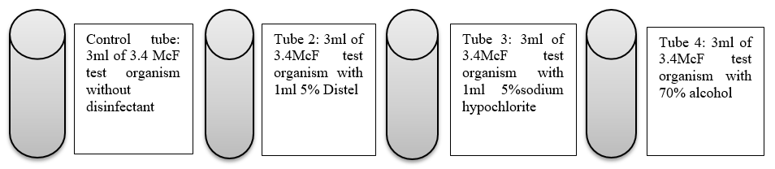
Figure 1. Illustration of quantitative suspension test

Eight plastic tubes were used for this analysis, the first 4 tubes contained 3ml of 3.4McF suspension for the test organism identified. The second 4 tubes contained 3.1 McF suspension of the other organism identified. The first tube of each 4 tubes was designated as the control tube which contained suspension of the test organism without disinfectant. The other 3 tubes contained the same suspension of the test organisms with 1ml of each of the 3 types of disinfectants that are being evaluated as explained in the figure above.
In summary, 1mL of the disinfectant being tested was pipetted using a plastic Pasteur pipette and added into a 3ml standardized microbial suspension. This activity was performed at room temperature for contact times of 0, 5, 10, and 15 minutes. The timer was started when the test bacterial suspension and disinfectant are combined. At 0 times, McFarland readings were taken using DensiCHEK™ plus instrument and at 5 minutes intervals, each test sample was re-suspended using a vortex mixture then turbidity readings were taken and recorded. After all, readings were taken and recorded, each test sample was cultured onto half plates with 5% BA and MCA then the plates were incubated overnight at 37°C in CO₂. Turbidity together with colonies on the plates where observed, disinfectant activity was compared, and the results were recorded.
Results and Discussion
The study assessed the efficacy of common laboratory surface disinfectants (70% alcohol, 5% sodium hypochlorite, and 5% Distel- quaternary ammonium compounds). Before the examination was carried out, a sterility check of the medium plate and saline was performed to ensure that the products were not contaminated. Identification of test organisms isolated from the Microbiology, Chemistry, and Haematology surface bench before disinfection is presented in the following table:

Table 2. Identification of Test microorganisms
Surface bench | Colonial morphology | Gram stain  results | Vitek 2 results
Microbiology culture bench | Grayish white, flat, and slightly mucoid colonies on BA, no growth on MCA | Gram positive bacilli | Staphylococcus lentus M155
Haematology RH bench | Grayish white, flat, and slightly mucoid colonies on BA, no growth on MCA. | Gram positive bacilli | Staphylococcus lentus M155
Chemistry HBA1C bench | Cream raised shiny and mucoid colonies on BA. Translucent colonies on MCA indicate that it is a non-lactose fermenter. | Gram negative bacilli | Acinectobacter lwoffii ATCC-15309

The organisms used in the sthudy were identified and verified as summarised in Table 2 prior laboratory testing. Staphylococcus lentus M155 strain was isolated from the microbiology and hematology laboratories' surface benches before disinfection and on the chemistry surface bench, Acinectobacter lwoffi strain ATCC-15309 was isolated pre-disinfection. Staphylococcus lentus is a Gram-positive bacillus, oxidase-positive, coagulase-negative member of the bacterial genus Staphylococcus consisting of clustered cocci. Staphylococcus lentus is a common part of the normal flora of both humans and other animals. However, it can be pathogenic to humans and cause endocarditic peritonitis, septic shock, infections of the urinary tract, a pelvic inflammatory disease most frequently, and wound infections. Acinectobacter lwoffi is a non-fermentative Gram-negative bacillus bacterium that is a member of the genus Acinetobacter. It is considered normal skin flora and can also inhabit the human oropharynx and perineum. It can cause infections in human hosts such as catheter-urinary infections in immunocompromised patients and gastroenteritis.
Acinectobacter lwoffi and Staphylococcus lentus were the two test organisms used to examine the efficacy of the three surface disinfectants used at the laboratory. The following are the results of the agar plate method using Staphylococcus lentus as a test organism:

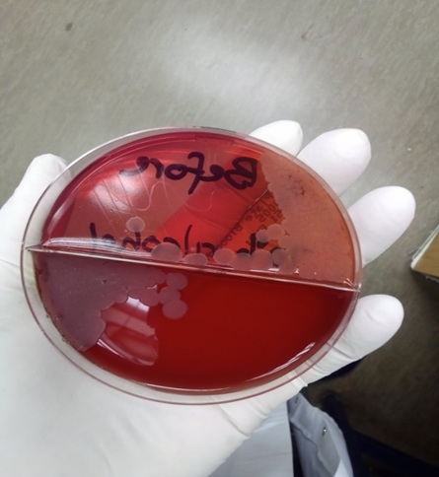
Figure 2. Before disinfection

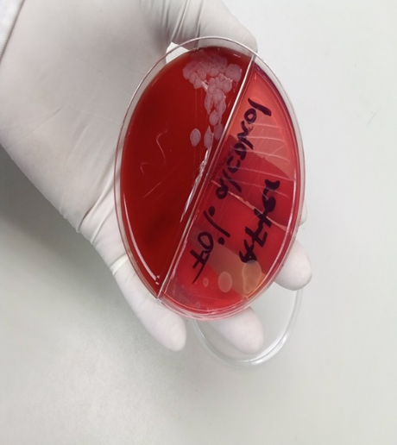
Figure 3. After disinfecting with 70% alcohol
The above figures show two mediums with growth before and after disinfection with 70% alcohol. Figure 2 shows 2+ growth on both BA and MCA whereas Figure 3 shows 1+ growth on BA and no growth on MCA. This indicates that the test organism survived and recovered from the BA plate even after disinfecting with 70% alcohol.
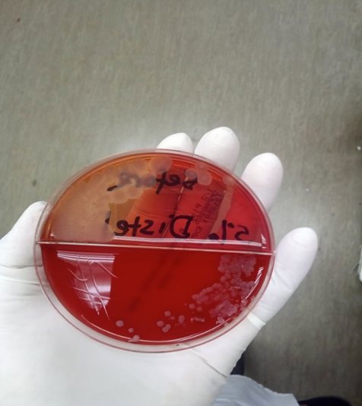
Figure 4. Before disinfection

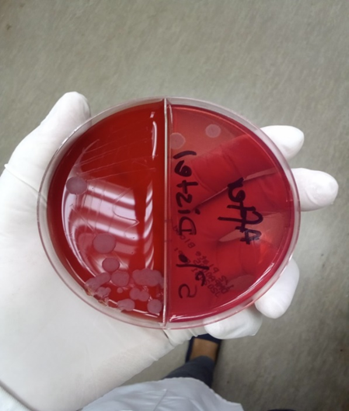
Figure 5. After disinfection with 5% Distel
Figures 4 and 5 show two mediums of before and after disinfection with 5% Distel/ quaternary ammonium compounds. There was a 2+ growth of the test organism on both BA and MCA in Figure 4. In Figure 5 there was 1+ growth of the test organism on BA but there is no growth on the MCA plate. This indicates that there was recovery and survival of the organism on BA but on MCA the organism was killed.
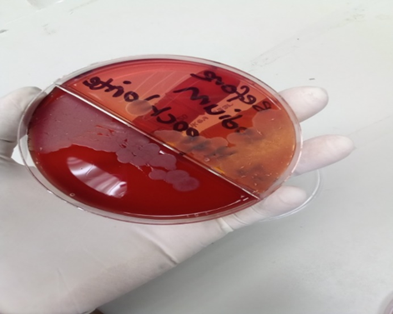
Figure 6. Before disinfection

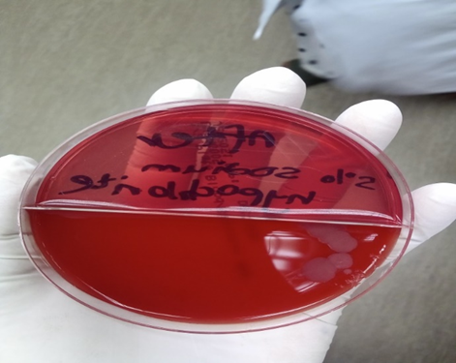
Figure 7. After disinfection with 5% sodium hypochlorite
Figures 6 and 7 show two mediums of before and after disinfection with 5% sodium hypochlorite. There was 3+ growth of the test organism on both BA and MCA in Figure 6. In Figure 7 there were less than 5 colonies on BA and no growth on MCA, this indicates that the microorganism was completely killed after disinfection with 5% sodium hypochlorite.
The killing rate of disinfectants was also evaluated; the following line graph is a result of McFarland value versus time using Staphylococcus lentus as a test organism:

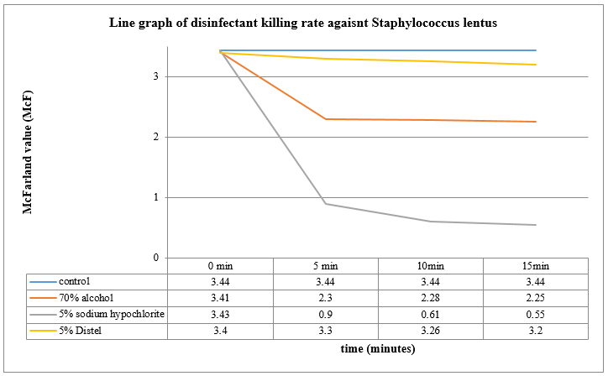
Figure 8. Bar graph showing McFarland value versus time using Acinectobacter lwoffi as a test organism:

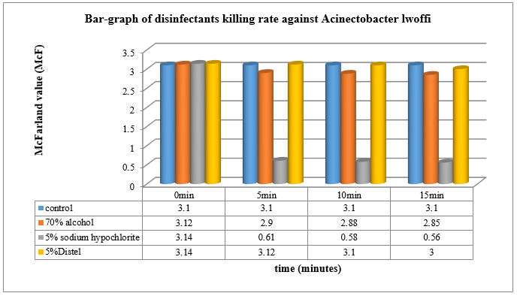
Figure 9. Bar-graph of disinfectants killing rate against Acinetobacter lwoffi

Analysis of both graphs shows that disinfection with 5% Distel after 15 minutes of contact time, did not make any major difference because the McF value remained at a range of 3McF. When looking at the killing rate of 70% alcohol, there was a slight decrease in McF value after a contact time of 15 minutes with the test organisms in Figure 8. Disinfection with 5% sodium hypochlorite showed a sharp decrease in McF value within 5 minutes of contact time with the test organism. Therefore 5% sodium hypochlorite is a fast microbial killer than 5% distal and 70% alcohol as shown in both Figures 8 and 9. The outcome of this study shows the importance of monitoring and evaluating the disinfectants that we use. In a study by Enitan in 2017 it was reported that the bactericidal activity of 30% sodium hypochlorite was unsatisfactory to kill other bacteria after 10 minutes of contact time, it’s also important to understand the organism mostly isolated in your laboratory benches as the two are normal floras. This non-correlation with our study could be attributed to the different concentrations of sodium hypochlorite and organisms of interest also as mentioned in the literature review, the concentration of disinfectant is one of the factors that affect the efficacy of disinfectants.
When examining the turbidity of the tubes containing a mixture of test organism suspension with 1ml of each disinfectant allocated in different tubes the following resulted:

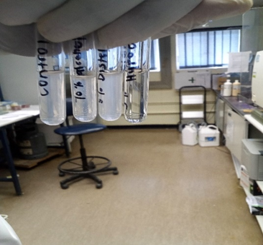
Figure 10. Turbidity of tubes containing test organism suspension with different types of disinfectants.
Figure 10 shows the turbidity results of the quantitative suspension test. The first tube is the control tube which contained suspension of the test organism without disinfectant. The other 3 tubes contained the same suspension of the test organisms with 1ml each of 70% alcohol, 5% distal, and 5% sodium hypochlorite respectively. It is observed that the two tubes containing 70% alcohol and 5% distal remained turbid when compared to the control tubes whereas the tube containing 5% sodium hypochlorite was not turbid but it was translucent. According to the results, Acinectobacter lwoffi and Staphylococcus lentus still survived in the tube containing 70% alcohol and 5% distal after 15 minutes of exposure time but, in the tube containing 5% sodium hypochlorite, the two test organisms were completely killed after the 15 minutes exposure.
When looking at the plates cultured from the quantitative suspension test method the following results:

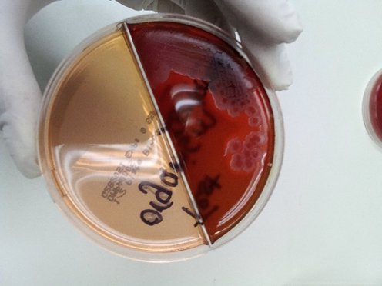
Figure 11. Control plate containing an only suspension of Staphylococcus lentus

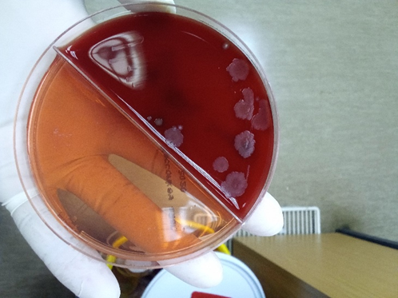
Figure 12. Plate containing a suspension of Staphylococcus lentus with 70%alcohol.

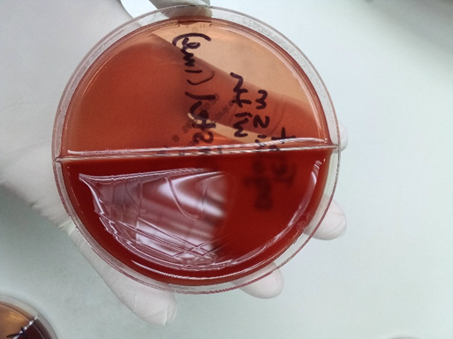
Figure 13. Plate containing a suspension of Staphylococcus lentus with 5% Distal

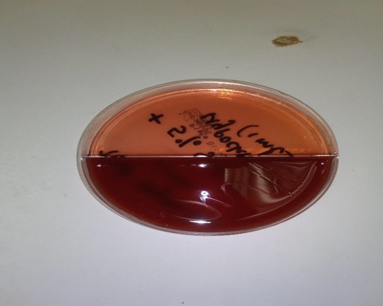
Figure 14. Plate containing a suspension of Staphylococcus lentus with 5% sodium hypochlorite.

The bactericidal effect (Logarithm reduction factor) of the disinfectants was determined by subtracting the logarithm of the survivors after disinfectant contact from the logarithm of the original inoculum in control plates, using the following formula:
Logarithmic Reduction Factor (RF) = Log Nc – Log Nd | (1)
Where:
Nc = Number of colonies from control plates (No disinfectant)
Nd = Number of colonies from test plates (after contact with disinfectant)
On the control plate in Figure 11, there are approximately 100 colonies, 6 colonies on a plate in Figure 12, and no colonies on both plates in Figures 13 and 14. Therefore the following was calculated:
RF (70% alcohol) = Log 100 – Log 6  = 2 – 0.778  = 1.22  = 1Log | (2)
RF of 5% Distel and 5% sodium hypochlorite cannot be calculated because in mathematics log 0 is undefined as there are no growth (Figures 13 and 14). It's not a real number, you can never get zero by raising anything to the power of anything else. You can never reach zero, you can only approach it using an infinitely large and negative power. A summary of log reduction values is outlined below:
Table 3. Log reduction percentage
Log reduction | Percentage reduction
1Log reduction | 90%
2Log reduction | 99%
3Log reduction | 99.9%
4Log reduction | 99.99%
5Log reduction | 99.999%

Table 3 shows percentatage growth reduction as been converted from the RF calculation. In this case 1-log reduction corresponds to a reduction of 90 percent from the original concentration; therefore 70% alcohol only killed 90% of the test organisms. The greater the log reduction the more effective the product is at killing bacteria and other pathogens that can cause infections.
The outcome of the study shows that in both the agar plate method and quantitative suspension test, 70% alcohol was not an effective surface disinfectant. These results do not correlate with studies of Woodman in 1998, Russo in 2000, and Hormann in 2000 which reported that 70% alcohol was an effective disinfectant to fully eliminate bacteria. There is also a need to understand that surfaces might be contaminated by the different normal floras. The efficacy of 5% Distel quaternary ammonium compounds to eliminate surface microorganisms with the agar plate method was unsatisfactory but, with the quantitative suspension test method, the disinfectants showed to have completely inhibited the growth of Staphylococcus lentus after overnight exposure. This correlates with the study of Josephson (1997) and Gerba (2015) which reported that QACs reduce bacterial contamination on the surface and several infectious organisms in healthcare facilities.
Conclusion

Five percent sodium hypochlorite proved to be the most effective disinfectant to use on laboratory surfaces as it completely inhibited the growth of the microorganisms within 5 minutes of exposure using both the agar plate method and quantitative suspension test. 5% Distel-quaternary ammonium compounds were also found to be effective disinfectants to use on laboratory surfaces but, it requires a prolonged contact time with the organism for the disinfectant to kill the microorganism. 70% alcohol has proven to be the most unsatisfactory disinfectant to use because all the test microorganisms recovered and survived after prolonged exposure to the disinfectant.
Therefore 5% sodium hypochlorite is recommended to be used as laboratory surface disinfectant after every shift in order to control or prevent infection transmissions and to ensure that the laboratory employees working on benches are protected and the working environment is safe. The outcome of this study further strengthened earlier works and underscored the need to periodically assess the efficacy of disinfectants routinely supplied to the laboratory to ensure proper control of infections by using the right disinfectant in the right concentration for the right contact time.
Acknowledgments: None
Conflict of interest: None
Financial support: None
Ethics statement: None
References
- Petitti DB, Crooks VC, Buckwalter JG, Chiu V. Blood pressure levels before dementia. Arch Neurol. 2005 Jan;62(1):112-6.
- Hallal AH, Amortegui JD, Jeroukhimov IM, Casillas J, Schulman CI, Manning RJ, et al. Magnetic resonance cholangiopancreatography accurately detects common bile duct stones in resolving gallstone pancreatitis. J Am Coll Surg. 2005 Jun;200(6):869-75.
- Stockhausen L, Turale S. An explorative study of Australian nursing scholars and contemporary scholarship. J Nurs Scholarsh [Internet]. 2011 Mar [cited 2013 Feb 19];43(1):89-96. Available from: http://search.proquest.com/docview/ 858241255
- Kanneganti P, Harris JD, Brophy RH, Carey JL, Lattermann C, Flanigan DC. The effect of smoking on ligament and cartilage surgery in the knee: a systematic review. Am J Sports Med [Internet]. 2012 Dec [cited 2013 Feb 19];40(12):2872-8. Available from: http://ajs.sagepub.com/content/40/12/2872 doi:10.1177/0363546512458223
- Carlson BM. Human embryology and developmental biology. 4th ed. St. Louis: Mosby; 2009. 541 p.
- Shreeve DF. Reactive attachment disorder: a case-based approach [Internet]. New York: Springer; 2012 [cited 2012 Nov 2]. 85 p. doi:10.1007/978-1-4614-1647-0
- Rowe IL, Carson NE. Medical manpower in Victoria. East Bentleigh (AU): Monash University, Department of Community Practice; 1981. 35 p. Report No.: 4.
- A.D.A.M. medical encyclopedia [Internet]. Atlanta (GA): A.D.A.M., Inc.; c2005. Ear barotrauma; [updated 2006 Oct 20; cited 2006 Nov 16]; [about 4 screens]. Available from: http://www.nlm.nih.gov/medlineplus/ency/article/001064.htm
- AHFS consumer medication information [Internet]. Bethesda (MD): American Society of Health-System Pharmacists, Inc.; ©2008. Protriptyline; [revised 2007 Aug 1; reviewed 2007 Aug 1; cited 2008 Oct 2]; [about 5 p.]. Available from: http://www.nlm.nih.gov/medlineplus/druginfo/meds/a604025.html
- Diabetes Australia. Diabetes globally [Internet]. Canberra ACT: Diabetes Australia; 2012 [updated 2012 June 15; cited 2012 Nov 5]. Available from: http://www.diabetesaustralia.com.au/en/ Understanding-Diabetes/Diabetes-Globally/
- Australian Medical Association [Internet]. Barton ACT: AMA; c1995-2012. Junior doctors and medical students call for urgent solution to medical training crisis; 2012 Oct 22 [cited 2012 Nov 5]; [about 3 screens]. Available from: https://ama.com.au/media/junior-doctors -and-medical-students-call-urgentsolution-medical-training-crisis.
- Centres for Disease Control and Prevention. Shingles on the face. [image on Internet]. 2011 [updated 2011 Jan 10; cited 2012 Nov 6]. Available from: http://www.cdc.gov/shingles/about/photos.html
- Clarke J, Pines A, McDermott RF, Trabesinger AH, inventors. University of California, assignee. SQUID detected NMR and MRI at ultralow fields. European Patent 1474707. 2004-11-10.
- Luca J, Tarricone P. Does emotional intelligence affect successful teamwork? In: Kennedy G, Keppell M, McNaught C, et al, eds. Meeting at the Cossroads: Proceedings of the 18th Annual Conference of the Australasian Society for Computers in Learning in Tertiary Education, 2001 Dec 9-12; Melbourne: Biomedical Multimedia Unit, The University of Melbourne; 2001. p.367-76.
- Cloherty SL, Dokos S, Lovell NH. Qualitative support for the gradient model of cardiac pacemaker heterogeneity. In: Proceedings of the 2005 IEEE Engineering in Medicine and Biology 27 Annual Conference [conference proceedings on the Internet]; 2005 Sep 1-4; Shanghai, China. New York: IEEE; 2005 [cited 2013 Sep 2]. p. 133-6. Available from: IEEE Xplore

